Hobart Barcode Scanner Setup Instructions

Installing the software:
Please install the Motorola scanner SDK for the type of Windows you are running (32 / 64 bit).

Configuring the Scanner
- Connect scanner to the host PC via the USB cable.
- Print a copy of the program scanner pdf file located in the supplied zip file.
- Under the Motorola Scanner directory, Scanner SDK directory, run the C++ Sample Application.
- Select the “Discover scanners” button to discover connected scanner.
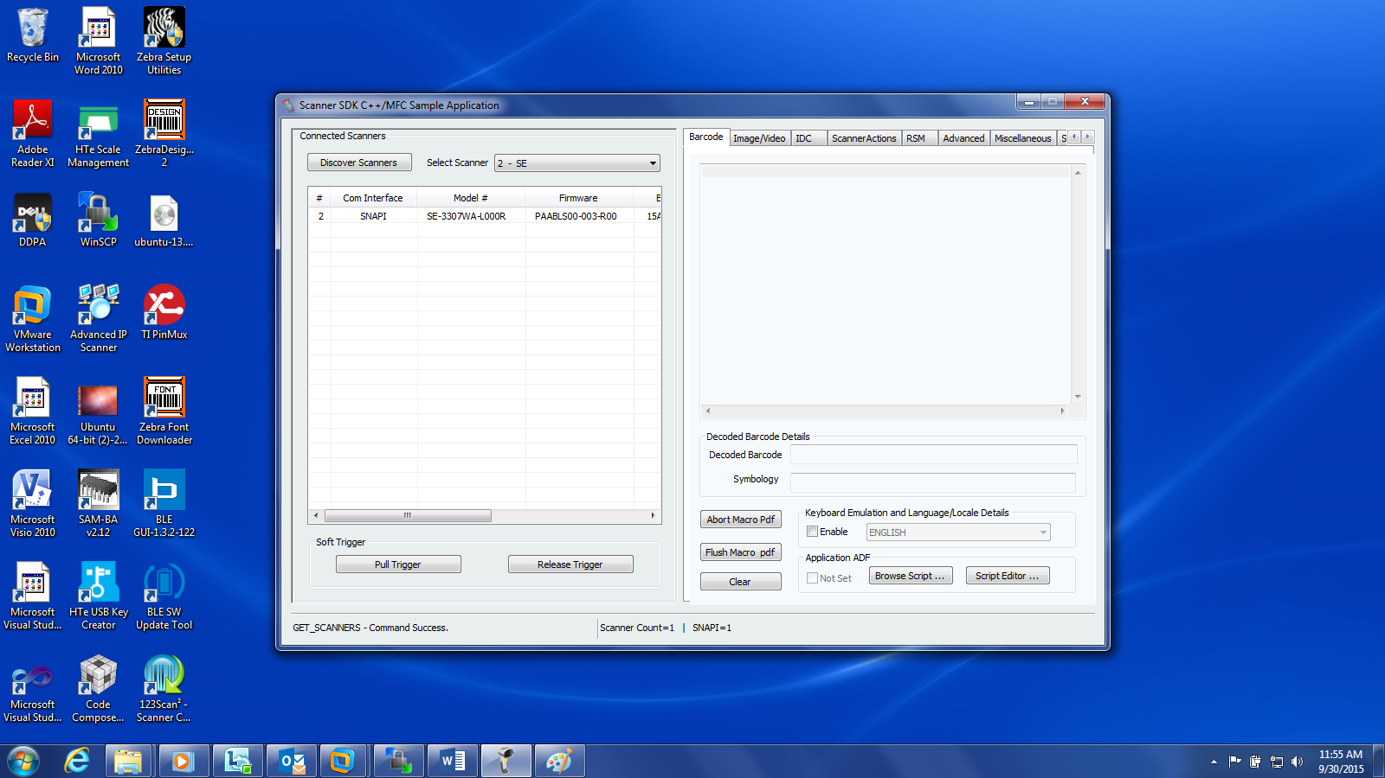

- Select the “Pull Trigger” button and a red light on the scanner should come on. Hold the scanner over the barcode labeled "Send Packet Decode Data (01h)“ until the light turns off on the scanner.
- Select the Pull Trigger” button and scan the barcode labeled “SSI over UBS CDC” until the light turns off on the scanner.
- Programming complete.

